Name: Christian Portelli  
Class: MSD_4.2A  
Subject: Programming for Computer Games

Home assigment 1  
Designing and creating a basic 2D game

**Question 1 (AA1, AA2)**

1. Select 2 game engines (1 mark) and list 4 reasons (1.5 marks each) why one particular game engine was selected (giving advantages of the game engine) and why the other was not selected.

**Answer:**

* Unity
* Construct

1. I prefer Unity because in all the games that we did on Unity needed to be coded on C# while on Construct 2 all games where done by selecting the actions, this is because by programming you could do more things and there aren’t a lot of limitations.
2. Unity Programmed Games could be used on many Platforms where on Construct 2 it is limited.
3. On Construct 2 free edition the maximum layers on layouts is that of 4 layers on each layout while on Unity it is unlimited.
4. On Unity you can do unlimited effects on each project while on Construct 2 free edition has a limited amount of 2 effects per project.
5. Select 2 programming languages (1 mark) used in game development and choose one to support the game engine chosen and list 4 of its features (1.5 marks each)

**Answer:**

* Java
* C#

1. C# forms part of Microsoft Visual studio.
2. C# is modern.
3. C# is a simple programming language.
4. C# can be used and edited by Unity.

**Question 2 (SE1):**

1. One Game design document (State Diagram) should contain an overview of the whole game, from the Start Menu till the end showing correctly the interactions between the scenes.

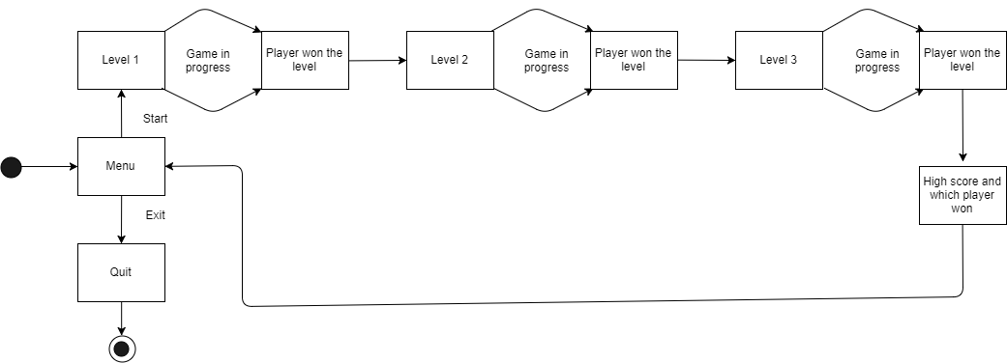

1. The second design document should contain a detailed State Diagram of either Level 2 or Level 3 of the game showing correctly all events and interactions happening in the scene.

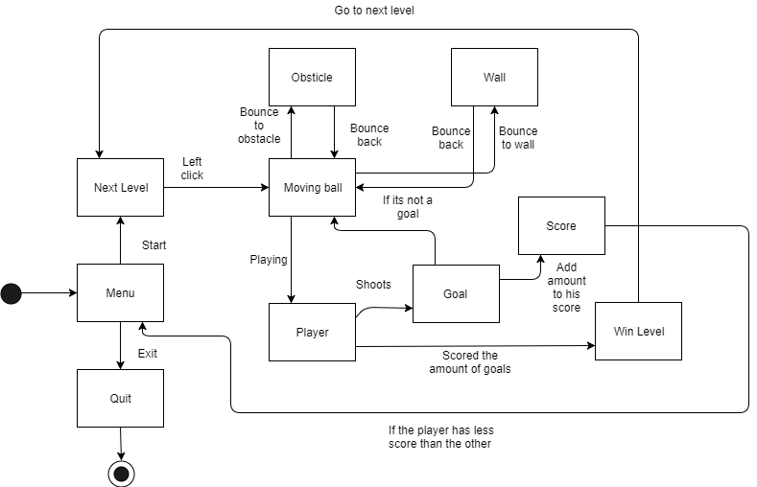

**Question 3 (KU 4)**

In not less than 100 words, explain why compression is needed when using media assets such as images, videos and audio. Provide examples.

**Answer:**

Compression is needed when using media assets because if we are creating a game and we don’t compress our images or videos the game will take a lot of storage, so by compressing your decreasing the storage space of these type of files. Also, when compressing these type of files, it will take less time to file transfer since the file size would be smaller. Compressing images also helps some devices for example Hard drives that take time to load uncompressed files because the large amount of storage that they hold, by compressing them it would help these devices to load them quickly.

